**Research Topics for Dissertation (on Adaptation)**

Experiment Paradigm:

1. production expectation

Setting: such as gumball machine (underinformed listener and objective speaker)

asking participants to distribute % (choices among a random pair of expressions)

three trials each, 0%, …, 100% for ratio of colourful gumballs (different settings)

1. adaptation of expectation (new participants)

Exposure: replay-able video/audio of a specific speaker producing one utterance

**1. Listener Adaptation on Negated Uncertainty Expressions**

While negation is generally used in related experiments to set polarities, research on adaptation focuses more on positive forms of expressions. In some cases, negation is solely for enriching exposure type. How or whether negation affects adaptation is rarely discussed.

* Research Questions

Does negation affect the extent of adaptation? (comparison with positive forms, extent as in the difference of the movement of the threshold)

Does negation weaken the difference between cautious and confident speakers? (where in positive forms, confident speaker has a lower threshold)

* Materials for Utterances

You’re unlikely to / You’re not likely to / You’re probably not / …

You might not / You could not / …

It doesn’t look like / I don’t think / …

* Difficulties

How to avoid pragmatic influence such as euphemism on primary expectation choices? (if unavoidable, does it influence adaptation outcome?)

How to design a situation where people are prone to speak in a negative form when the positive one conveys the same semantic meaning?

**2. Listener Adaptation on Epistemic Modals: Present and Past Tense**

It is believed that the past tense of epistemic modals demonstrates a lower possibility than its present tense for English modals. (If there is any phenomenon, is it English specific?)

* Research Questions

Does adaptation of the present tense affect the interpretation for the threshold of the past tense and vice versa?

If shown a specific speaker who uses past and present tense in an opposite manner of probability, will adaptation carry out successfully? (with and without adequate exposure)

* Materials for Utterances

You may / might; You can / could; You will / would; You should

* Difficulties

How to make sure that modals in the utterance are interpretated only in terms of possibility?

How to provide enough exposure while not being too clear about the research aim?

**3. Listener Adaptation on Adjectives**

In Xiang & Kennedy’s experiment, threshold is determined by yes/no questions rather than the probability assumed by the listener. (categorical-continuous contrast in experiment)

* Materials for Utterances (different types of adjectives)

- Semantic Adaptation in Gradable Adjective Interpretation (2020)

RELATIVE (tall, big)

ABSOLUTE (MAXIMUM - bent striped open

MINIMUM - straight plain closed)

-Other gradable adjectives

Weight / Intelligence / Weather / Colour / …

* Difficulties

Research questions other than the ones have been mentioned are hard to find.

**4. Listener Adaptation on Time Adverbials**

* Research Questions

Does listener adapt to the period of time or to the relative position of the threshold?

* Materials for Utterances

**Future:** “we’re arriving ___” or “we will arrive ___”

now / soon / in a while / shortly / …

* Difficulties

For different activities, measurement could happen in minutes, hours, or days. How to narrow down the basic unit?

**Other Questions:**

1. Does threshold always mean a specific number, or could it be a range (an interval)?
2. RSA related: I’m still a little bit confused about the calculation of the last Lprag outcome from C to D.

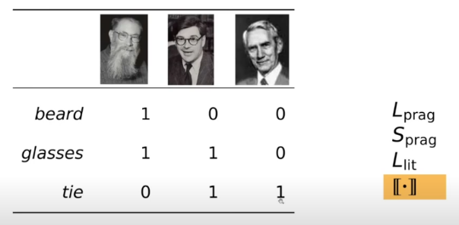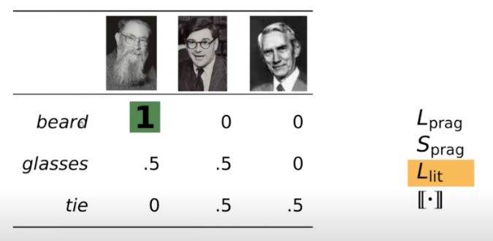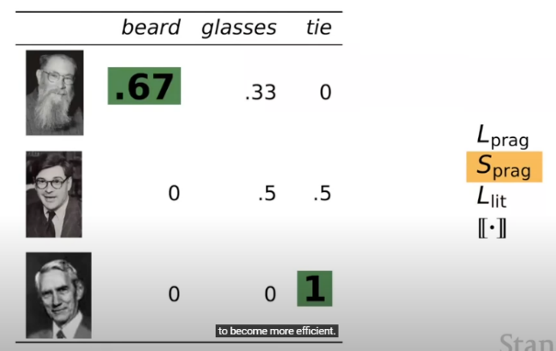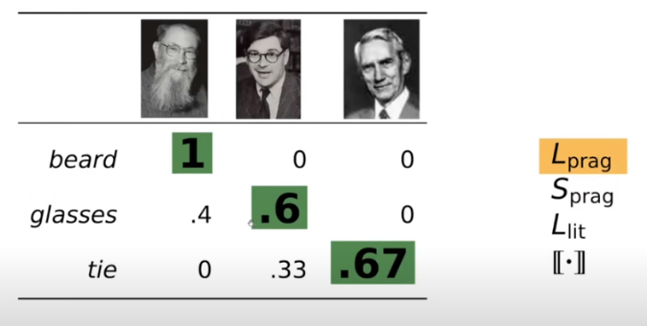

(From <https://www.youtube.com/watch?v=pkT0g7utr70>)

气泡图

For example in C, because the three figures only has one green figure, but two squares, it’s more likely for the speaker to say green. But I couldn’t figure out how for listener, the speaker using green for green square is 1 in D.